Computer Language Diagrams

Basic Diagram Elements
The diagrams are composed of only a small set of basic elements.

Shapes

6 basic shapes are used:

 | 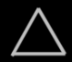 |  |  |  | 
Circle | Triangle | Square | Diamond | Pentagon | Nonagon

Lines

There are 3 line types:

 | 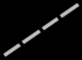 | 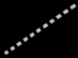
Solid line | Dashed line | Dotted line

Text

The diagrams also contain text. Shapes have names. Numbers and dates and other values also appear in the diagram.

My Object
My Site
7
3.141592
14-08-2005
"Hello"
True
False
On
Off
A = B + C

Custom expressions

Any kind of custom way to express an object can be also be embedded into the diagram.

Circles & triangles

Circles and triangles represent objects, classes and interfaces.
Objects can serve as prototypes for other objects. That way an object can serve as the class of another object. An object can also define the interface for another object. That’s why objects, classes and interfaces are all represented by the same type of shapes.

A triangle has a special function related to interfaces, that will be explained in another article.

Squares & diamonds

Squares and diamonds represent procedures. A square is an inactive procedure, that only runs when you call it. A diamond represents a call. A diamond executes, a square does not.

Pentagons

A pentagon represents a globality. A globality is like a little world in which objects and procedures live. A globality can be a site, a computer program, a library or other kind of module. A pentagon is considered an object just like circles and triangles, but a pentagon has a special purpose.

Nonagon

A nonagon represents collection. Objects can be placed inside the nonagon, to keep them grouped together. It is not required to draw a nonagon with exactly nine corners.

Object symbols

Circles, triangles, pentagons and nonagons are called object symbols, because they represent objects.

Circle | Triangle | Pentagon | Nonagon

Procedure symbols

Squares and diamonds are called procedure symbols, because they represent procedures.

Square | Diamond

Solid line

A solid line represents an object. Object symbols connected by solid lines represent the same individual object.

Dashed line

A dashed line represents a definition or class. Object symbols connected by dashed lines have the same class.

Dotted line

A dotted line represents an interface. Shapes connected by dotted lines have the same interface, so that they look the same from the outside, but are different on the inside.

Object symbols drawn with different lines
An object symbol can represent an object, a class or an interface.

Each object can serve as another object’s class, thus functioning as its prototype. Each object can also provide the interface for another object, giving another object the same exterior, while it is different on the inside.

If an object is only used as an object, not as a class or an interface, it is drawn with a solid line.

But if an object symbol is only used as a class, then it is drawn with a dashed line.

 | 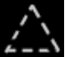 | 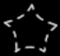 | 

If an object symbol is only used as an interface, then it is drawn with a dotted line.

 | 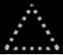 |  | 

If object symbols are used in several ways, for instance as an object as well as other objects’ class, the symbol gets multiple borders. Here’s an object symbol that servers as both an object and a class:



That way an object symbol can have a maximum of three borders at the same time.

Theoretically it is not required to draw symbols using different lines types; you could draw them all with solid lines, but it just works more intuitive to draw a symbol with a different line type based on its usage.

Procedure symbols drawn with different lines
A call is always something that is created and instatiated when run, a method definition is always a definition, that is never created itself. In that sense a call is more like an object, and a procedure definition is more like a class.

If you draw the procedure symbols with a line type conforming to their usage, then diamonds, that represent calls, would always be drawn with a solid line, but squares, which represent procedure definitions, would always be drawn with a dashed line.

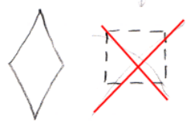

But a square already clearly defines that it is a procedure definition, so drawing it with a dashed line is not necessary to further denote it is a definition.

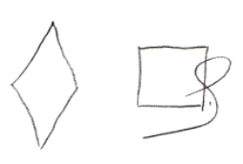

This does not mean, that you could also simply abolish the diamond shape, and only use solid and dashed squares to represent the difference between a call and a procedure definition: using different line types is only an extra. The diagram should be able to express things unambiguously without using different line types for shapes.

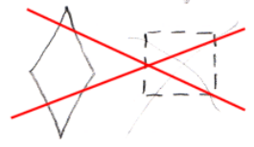

A diamond, which represents a call, can be used as a procedure definition, but this is not common for a diamond. In that case a diamond gets both a solid border and a dashed border.

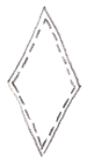

Both procedure calls and procedure definitions can function as the interface for another procedure symbol. In that case the procedure symbol gets an extra dotted border.

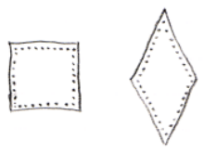

Connecting object symbols
Object symbols can be connected by different types of lines.

If two object symbols are connected by a solid line, it means that both symbols represent the same individual object.



Lines do have a direction, going from one symbol to the next, which will be explained later. Having a direction, an object line can point out which object an object symbol will represent. The solid line is called an object line in this case, because it points out the object.

If two object symbols are connected by a dashed line, it means that both symbols have the same class, which means they have the same behavior, but are not the same individual object.



Lines do have a direction, going from one symbol to the next, which will be explained later. A class line points out, what class an object has. The dashed line is called a class line in this case, because it points out the class for the object.

If two object symbols are connected by a dotted line, it means that both symbols have the same interface, which means that they look the same from the outside, but are different on the inside.



The two symbols are separate individual objects, they also have a different class, so behave differently, but from the outside they look the same. Lines do have a direction, going from one symbol to the next, which will be explained later. An interface points out the interface of the object. A dotted line is always an interface line.

Connecting procedure symbols
Procedure symbols can be connected by different types of lines.

In theory, a call line should be dashed, because it points to the definition for the call. But when you draw a call line with a solid line, it is clear enough you are pointing out the definition for the call. To keep the diagram simple, the definition line for a call is simply drawn with a solid line.

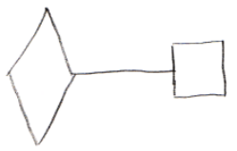

When procedure definitions, squares, are connected to eachother, it should in theory also be done with a dashed line, because it makes them represent the same definition, not the same individual call. But it is already clear, that only the definition of the two symbols is the same, so you don’t use the dashed line, you just use a solid line.

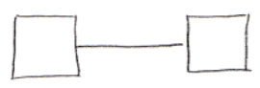

So a solid line between procedure symbols is always a definition line. Procedure symbols are never drawn in dashed lines.

There isn’t much use to letting two diamonds represent the same individual call to a procedure. So you would never need a solid line to let two symbols represent the same instance of a procedure. That’s why the solid line can always be applied for pointing out the definition of a procedure symbol.

Two procedures can have the same interface, which means that one procedure has the same parameters as the other procedure. Procedure symbols that have the same interface are connected using dotted lines:

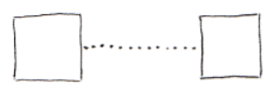

A dotted line is always an interface line.

Author & Copyright: Jan-Joost van Zon Date: May 19, 2008 – May 20, 2008 Location: Oosterhout, The Netherlands Status: Finished

